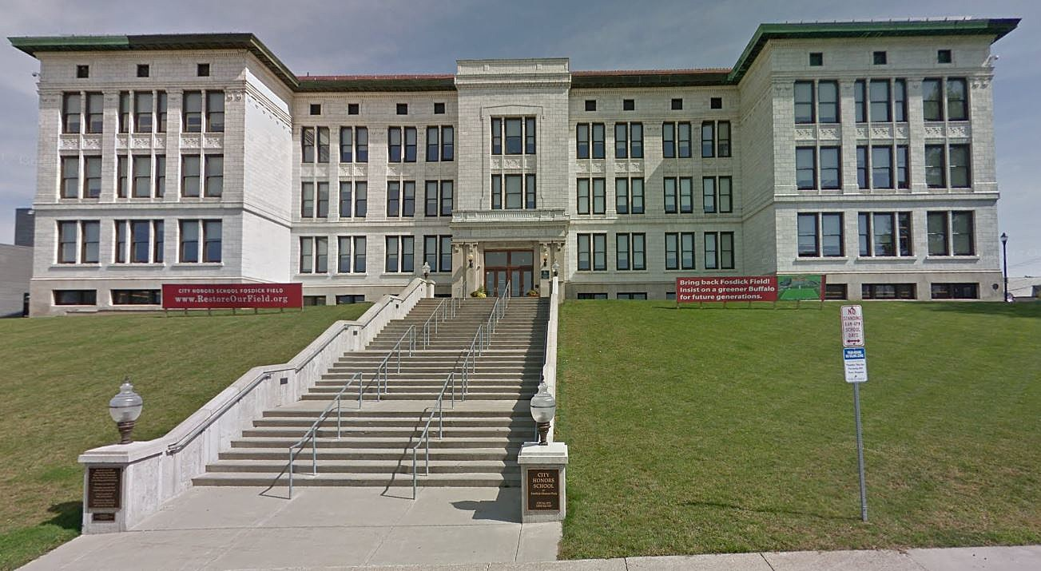

MINIMUM CAPACITY :-
The Minumum intake capacity
of students is between 150-350
children

LIBRARY :-
The Libarary is Available.

CANTEEN:-
The Canteen Facility is Available.

BOARDING :-
No availablility of boarding.

SPORTS :-
There are different categories
sports available.
Girls Volleyball
Boys Volleyball
Football

CITY HONORS PS 195
BUFFALO - SCHOOL

School Detail :-
City Honors School at Fosdick-Masten Park, known colloquially as City Honors, or CHS, is a college preparatory school in Buffalo, New York, United States. It is part of the Buffalo Public Schools system.
P.S. 195 - City Honors School is a highly rated, public, magnet school located in BUFFALO, NY. It has 1,073 students in grades 5-12 with a student-teacher ratio of 13 to 1. According to state test scores, 90% of students are at least proficient in math and 87% in reading.

